ATM Monitoring System - Data Model

## **Introduction**

This document outlines the data model design for an ATM service that operates on ATM devices. The service interacts with a monitor service for authentication and logging purposes. The monitor service also facilitates access to various data by other bank services.

## **System Overview**

The ATM service is responsible for handling transactions on ATM devices. It authenticates with a monitor service and logs transaction outcomes. The monitor service manages these logs and provides data access to other bank services.

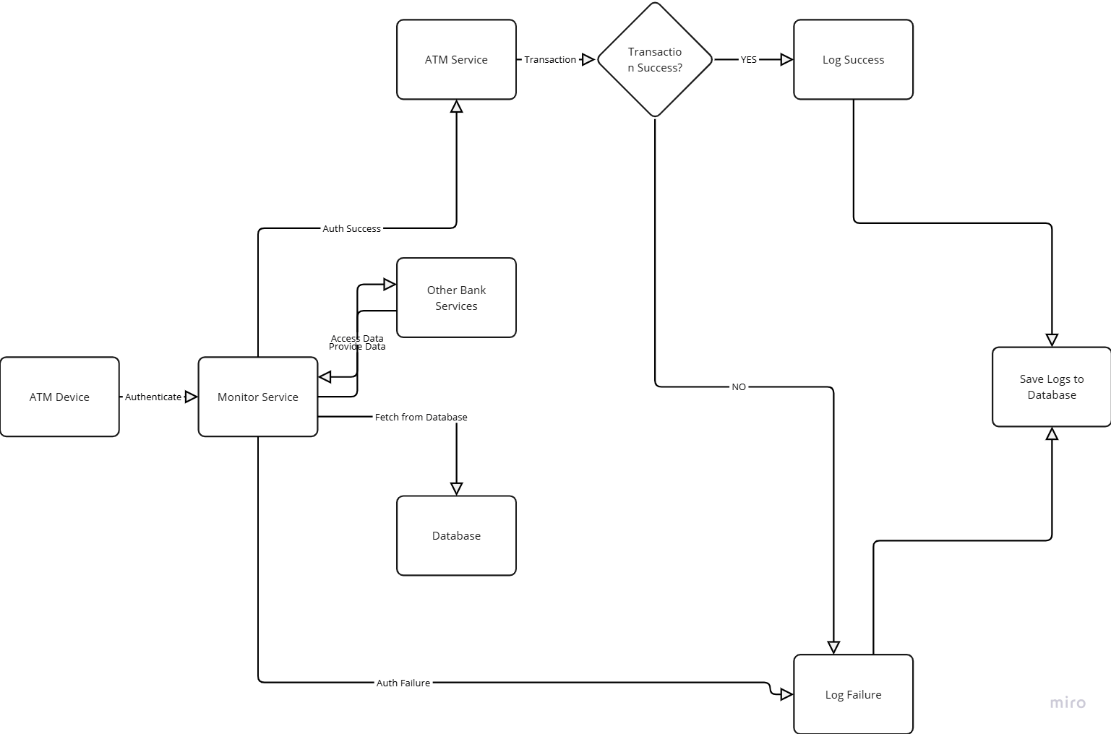

## 

## 

## **Data Model Components**

### **Entities**

1. **Transaction**
   * **Attributes:**
     + ID
     + ATM Device ID
     + Customer ID
     + Bank
     + Timestamp
     + Transaction Type(Deposit/Withdraw)
2. **Failures**
   * **Attributes:**
     + ID
     + ATM Device ID
     + Customer ID
     + Bank
     + Timestamp
     + Transaction Type(Deposit/Withdraw)
     + Failure Type
3. **Video**
   * **Attributes:**
     + Video ID
     + ATM Device ID
     + Timestamp
     + File Path

### **Relationships**

* **ATM Device to Transaction:** One-to-Many
  + Each ATM device can process multiple transactions.
* **Customer to Transaction:** One-to-Many
  + Each customer can perform multiple transactions.
* **Transaction to Log:** One-to-One
  + Each transaction has a corresponding log entry.
* **ATM Device to Video:** One-to-Many
  + Each ATM device can have multiple video recordings.

## **Data Flow**

1. **Authentication:**
   * ATM devices authenticate with the monitor service before processing transactions.
2. **Transaction Processing:**
   * Transactions are initiated on ATM devices and logged with the monitor service.
3. **Logging:**
   * Transaction success and failure logs are sent to the monitor service, which stores them in the database.
4. **Data Access:**
   * Other bank services access customer lists, transaction failure data, and video downloads through the monitor service.

## **Database Design**

### **Tables**

1. **ATM_Devices**
   * Columns: Device_ID, Location, Status
2. **Transactions**
   * Columns: Transaction_ID, ATM_Device_ID, Customer_ID, Amount, Timestamp, Status
3. **Customers**
   * Columns: Customer_ID, Name, Account_Number, Contact_Information
4. **Logs**
   * Columns: Log_ID, Transaction_ID, Timestamp, Status, Message
5. **Videos**
   * Columns: Video_ID, ATM_Device_ID, Timestamp, Duration, File_Path

## **Security Considerations**

* Ensure secure communication between ATM devices and the monitor service.
* Implement authentication and authorization mechanisms for data access by other bank services.
* Encrypt sensitive data, such as customer information and transaction details.

## **Conclusion**

This data model design provides a structured approach to managing ATM transactions, logging, and data access through a centralized monitor service. It ensures efficient data handling and security across the ATM service ecosystem.